Food Ordering Website

Sanidhya khamkhar  
Thakur College of Engineering and Technology

*Informaition technology*Mumbai ,India  
sanidhyakhamkar313@gamil.com

Chetan Korde   
l*Thakur college of engineering and technology*  
 *Information technology* mumbai,India  
chetankorde0306@gmail.com

Yash Lohar

*Thakur college of engineering and technology*  
 *Information technology* mumbai,India  
loharyash6@gmail.com

*Abstract*— The goal of the online food ordering system is to automate the current manual system with the aid of computerised hardware and comprehensive computer software, meeting their requirements, in order to store their important data and information for a longer period of time with simple access and manipulation. The necessary gear and software are readily available and simple to use.The above-described online food ordering system can result in an error-free, secure, dependable, and quick management system. Instead of focusing on record keeping, it can help the user focus on their other activities. As a result, it will aid organisations in making better use of their resources. The company can keep computerised records updated without making duplicate inputs. The goal is to automate the company's current manual method with the use of computerised hardware and comprehensive computer software, meeting their specifications, in order to retain their important data and information for a longer period of time with simple access and manipulation. The project essentially outlines how to manage for improved performance and better customer services.

Keywords—Automated Food Ordering System, Dynamic Database Management, Responsiveness, Smart Phone

# Introduction

The programme is kept as simple as possible to reduce data entry errors. Additionally, it displays an error notice when you enter invalid data. The user doesn't require any formal training to use this system. This alone demonstrates that it is user-friendly. The above-described online food ordering system can result in an error-free, secure, dependable, and quick management system. Instead of focusing on record keeping, it can help the user focus on their other activities. As a result, it will aid organisations in making better use of their resources.

No matter how big or small a company is, managing the information for a category, food item, order, payment, and confirmed order is a challenge. We create unique personnel management solutions that are tailored to your managerial demands because every Online Food Ordering System has various Food Item needs. This is intended to aid with strategic planning and will help you make sure that your company has the appropriate level of information and specifics for your long-term objectives. Additionally, our systems have remote access features that will enable you to manage your staff whenever you need to, making them ideal for busy executives who are often on the road. In the end, these solutions will enable you to manage resources more effectively.

# Problem statement

The Online Food Ordering System's primary goal is to manage the information for Item Category, Food, Delivery Address, Order, and Shopping Cart. It oversees the management of all customer, shopping cart, and item category information. Since the project was entirely developed on the administrative end, only the administrator is assured access. The project's goal is to create an application software that will lessen the amount of manual work required to manage the food, customer, delivery address, and item category. It keeps track of every element pertaining to the delivery address, order, and shopping cart.

# Literature review

A suggested automated meal ordering system in [1] will intelligently track user orders. They essentially created a food ordering system for several types of eateries, allowing users to place orders or create custom meals with just one click. This technique was created using an Android application for tablet computers. Android and Java were used to construct the front end, and MySQL was used to power the back end.

A customer utilising a smartphone is regarded as the system's fundamental premise in [2]. The saved order can be verified by tapping the smartphone as the consumer approaches the establishment. The list of the preordered things you've chosen will appear on the kitchen screen, and once you've decided, an order sheet will print out so that you may continue processing your order. The solution offers a simple and practical approach to choose customers for pre-order transaction forms.

A design and implementation of digital eating in restaurants utilising Android technology was attempted in [3]. This solution was a straightforward dynamic database tool that retrieved all the data from a single database. This intuitive programme helped eateries operate more efficiently and accurately while reducing human error. This system overcame the previous shortcomings of automated food ordering systems and just needs a one-time investment in devices.

In [4] presents an application of web services technology used to integrate hotel management systems. The Digital Hotel Management holds the ordering system, billing system, and customer relationship management system (CRM) together. This approach made it possible to add or expand hotel software systems in environments with any size hotel chains.

A wireless meal ordering system for the restaurant is the focus of study in [5]. Wireless Ordering System (WOS) technical operations, including system architecture, function, restrictions, and recommendations, were described in this system. Pervasive applications were thought to be a key tool for restaurants to improve management by reducing human error and by offering higher-quality customer service as a result of the growing use of handheld devices like PDAs in dining establishments.

The aim of Paper [6] was to research the variables influencing internet users' perceptions of online food ordering among university students in Turkey. Davis' Technology Acceptance Model (TAM), which he created in 1986, was used to analyse how the Web environment for ordering food was adopted. Along with TAM, the fundamental components of trust, innovation, and external influences are incorporated to the model.

In [7], a wireless meal ordering system was designed and implemented together with consumer feedback for a restaurant. It makes it simple for restaurant operators to change menu presentations and set up the system in a wifi setting. In order to facilitate real-time contact between restaurant owners and patrons, a smart phone has been linked into the configurable wireless food ordering system with real-time customer feedback implementation.

In Paper [8], the research project attempts to automate the restaurant's food ordering process and also enhance the diners' dining experience. This study discussed the design and execution of a restaurant meal ordering system. The wireless data access to servers is implemented by this system. The user's mobile Android application will include all the menu information. Order details are wirelessly transmitted from the customer's mobile device to the kitchen and cashier. The central database is updated with these order specifics. The proprietor of the restaurant can quickly handle menu changes. The proprietor of the restaurant can quickly handle menu changes

# Methodolody

Model View Controller or MVC as it is popularly called, is a software design pattern for developing web applications. A Model View Controller pattern is made up of the following three parts:

Model - The lowest level of the pattern which is responsible for maintaining data.

View - This is responsible for displaying all or a portion of the data to the user.

Controller - Software Code that controls the interactions between the Model and View.

MVC is popular as it isolates the application logic from the user interface layer and supports separation of concerns. Here the Controller receives all requests for the application and then works with the Model to prepare any data needed by the View. The View then uses the data prepared by the Controller to generate a final presentable response. The MVC abstraction can be graphically represented as follows:

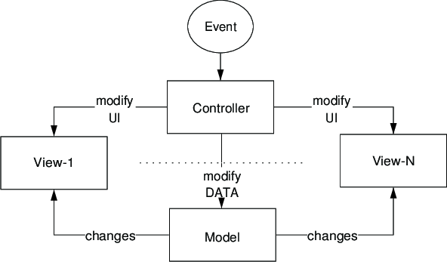

# PROPOSED SYSTEM

The operation of the online ordering system is quite simple. The piecemeal approach used in the analysis is described in the following.

1. Customers can view your building's menu or the menus of other restaurants you offer online, just in case third-party platforms are used.

2. Customers recognise the foundation of their emotions and select the meal they need to order.

3. Clients confirm their orders.

4. The users then had the choice of paying online or selecting COD for their items. The building receives these orders via the admin panel.

5. The edifice prepares the meal and packages the orders to fulfil the orders.

5.1 **Offered options**

The projected system aims to develop a system of improved facilities. The projected system will overcome all the restrictions of the present system. The system provides correct security and reduces manual work.

1. Admin Panel 2. Client-Side 3. Online Food Ordering 4. Manage Food classes 5. Manage Food things 6. Food Order Management 7. Online Accommodation 8. Manage Rooms classes 9. Manage Customers 10. System User Management 11. Total Revenue 12. Overview information

5.2 **System design**

The System flow chart diagram is a graphical representation of the relation between all the major parts or steps of the system. A flow chart diagram cannot include minor parts of the system.

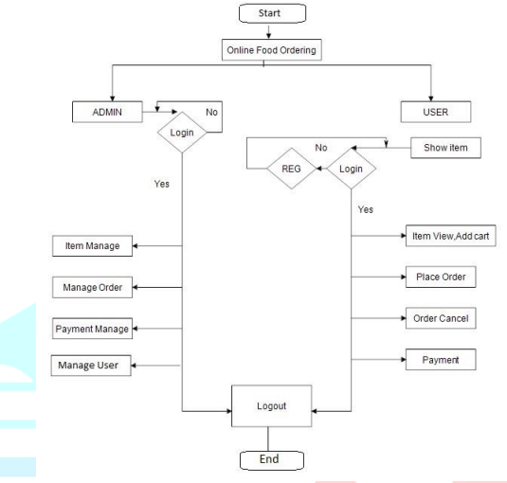

***Conclusion***

Using a system to detect liveness and recognize faces is an intriguing research strategy. In this method, the image will be captured by the camera. The Haar cascade classifier model is used to detect faces in the database. The photos are sent to the deep learning algorithm after the face has been found. Additionally, the automated system offers greater benefits over conventional ones because it is more accurate and saves time. An online food ordering system is developed where the customers can make an order for the food and avoid the hassles of waiting for the order to be taken by the waiter. Using the application, the end users register online, read the E-menu card and select the food from the e-menu card to order food online. Once the customer selects the required food item the chef will be able to see the results on the screen and start processing the food. This application nullifies the need of a waiter or reduces the workload of the waiter. The advantage is that in a crowded restaurant there will be chances that the waiters are overloaded with orders and they are unable to meet the requirements of the customer in a satisfactory manner. Therefore by using this application, the users can directly place the order for food to the chef online. In conclusion an online food ordering system is proposed which is useful in small family run restaurants as well as in places like college cafeteria, etc. This project can later be expanded on a larger scale. It is developed for restaurants to simplify their routine managerial and operational task and to improve the dining experience of the clients. This also helps the restaurant owners develop healthy customer relationships by providing reasonably good services. The system also enables the restaurant to know the items available in real time and make changes to their food and beverage inventory based on the orders placed and the orders completed.

##### Acknowledgment *(Heading 5)*

The preferred spelling of the word “acknowledgment” in America is without an “e” after the “g”. Avoid the stilted expression “one of us (R. B. G.) thanks ...”. Instead, try “R. B. G. thanks...”. Put sponsor acknowledgments in the unnumbered footnote on the first page.

##### References

[1]. Kirti Bhandge, Tejas Shinde, Dheeraj Ingale, Neeraj

Solanki, Reshma Totare,”A Proposed System for

Touchpad Based Food Ordering System Using Android

Application”, International Journal of Advanced

Research in Computer Science Technology (IJARCST

2015).

[2]. Varsha Chavan, Priya Jadhav,Snehal Korade,Priyanka

Teli, ”Implementing Customizable Online Food Ordering

System Using Web Based Application”, International

Journal of Innovative Science, Engineering

Technology(IJISET) 2015.

[3]. Resham Shinde, Priyanka Thakare, Neha Dhomne,

Sushmita Sarkar, ”Design and Implementation of Digital

dining in Restaurants using Android”, International

Journal of Advance Research in Computer Science and

Management Studies 2014.

[4]. Ashutosh Bhargave, Niranjan Jadhav, Apurva Joshi,

Prachi Oke, S. R Lahane,“Digital Ordering System for

Restaurant Using Android”, International Journal of

Scientiﬁc and Research Publications 2013.

[5]. Khairunnisa K., Ayob J., Mohd. Helmy A. Wahab, M.

Erdi Ayob, M. Izwan Ayob, M. Aﬁf Ayob, ”The

Application of Wireless Food Ordering System”

MASAUM Journal of Computing 2009.

[6]. Noor Azah Samsudin, Shamsul Kamal Ahmad Khalid,

Mohd Fikry Akmal Mohd Kohar, Zulkiﬂi Senin, Mohd

Nor Ihkasan,” A customizable wireless food ordering

system with real time customer feedback”, IEEE

Symposium on Wireless Technology and

Applications(ISWTA) 2011.

[7]. Serhat Murat Alagoza, Haluk Hekimoglub,” A study on

tam: analysis of customer attitudes in online food

ordering system”, Elsevier Ltd. 2012.

[8]. Patel Krishna, Patel Palak, Raj Nirali, Patel Lalit,”

Automated Food Ordering System”, International Journal

of Engineering Research and Development (IJERD)

2015.

[9]. Mayur D. Jakhete, Piyush C. Mankar,” Implementation

of Smart Restaurant with e-menu Card,” International

Journal of Computer Applications 2015 of Smart

Restaurant with e-menu Card, ”International Journal of

Computer Applications 2015.

[10] International Journal of Computer Applications (0975 – 8887) Volume 180 – No.6, December 2017

[11] Kondra Revathi Satya a , Ch Tejab , Ashish Shrivastavaa